Lab 1
Abdul Majid
24k-0895
BCS-5H
Task A:

Task # 1:
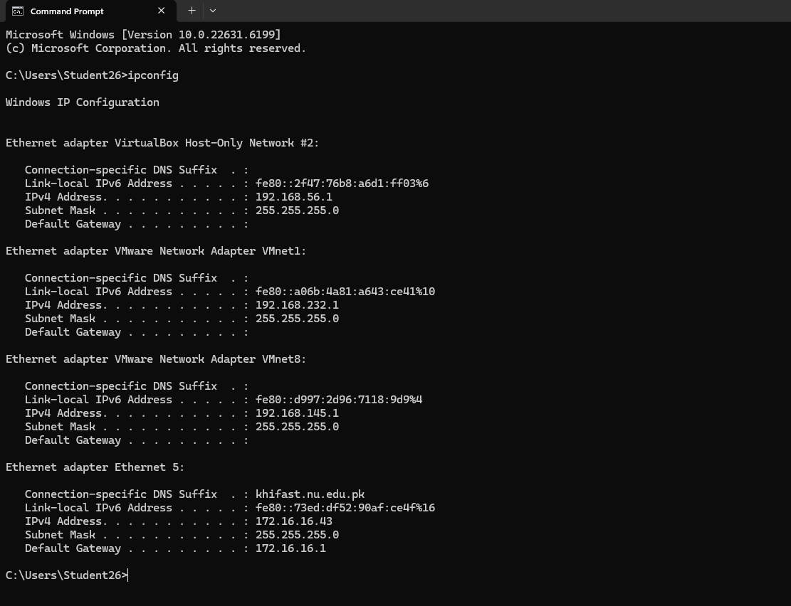

Command: ipconfig
IP Address: 172.16.16.43
IP Address Version: IPv4

Task # 2:
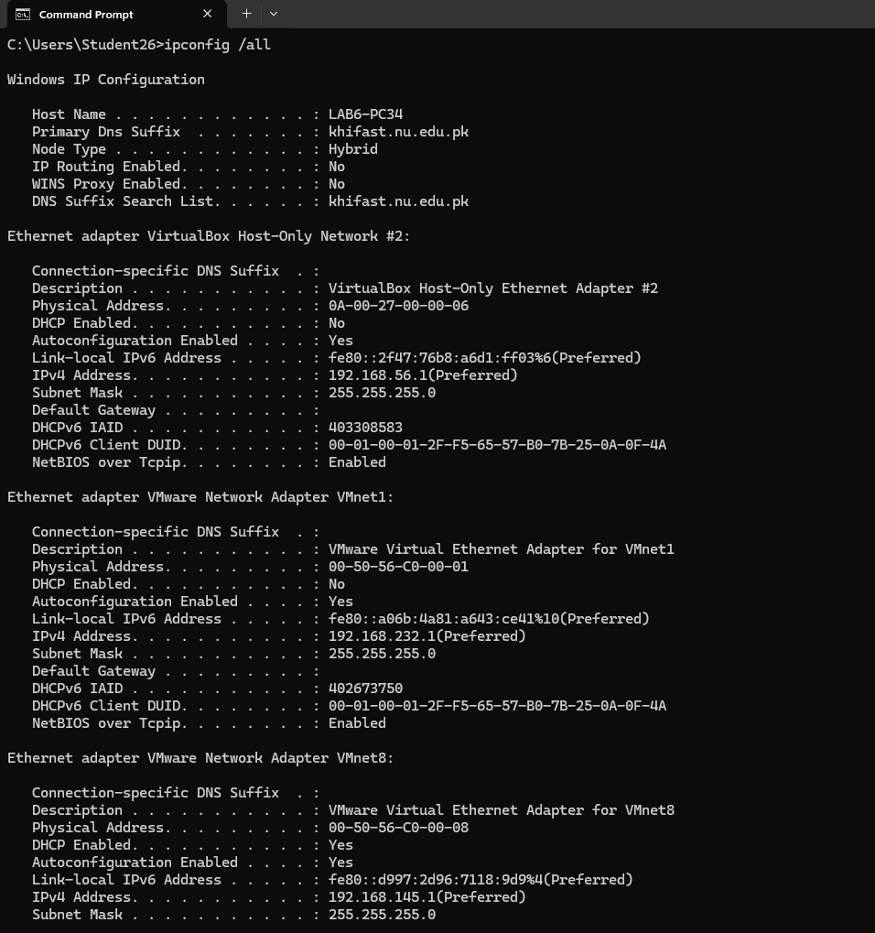
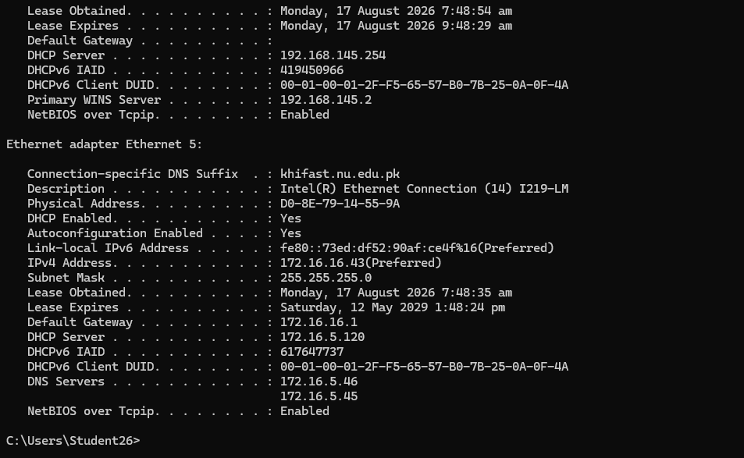
Command: ipconfig /all
Subnet Mask: 255.255.255.0
MAC Address: D0-8E-79-14-55-9A
Gateway: 172.16.16.1
DHCP Status: Enabled
Task # 3:
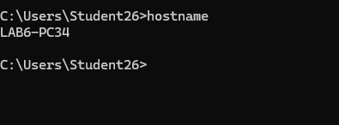
Command: hostname
Hostname: LAB6-PC34
Protocol Name: DNS needs to be installed

Task # 4:
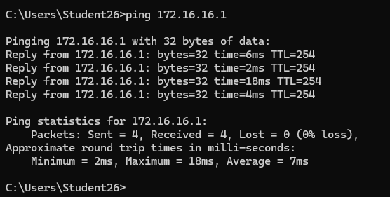
Command: ping 172.16.16.1
Reason: All 4 packets were send and received with 0% loss so the computer is reachable.

Task # 5:
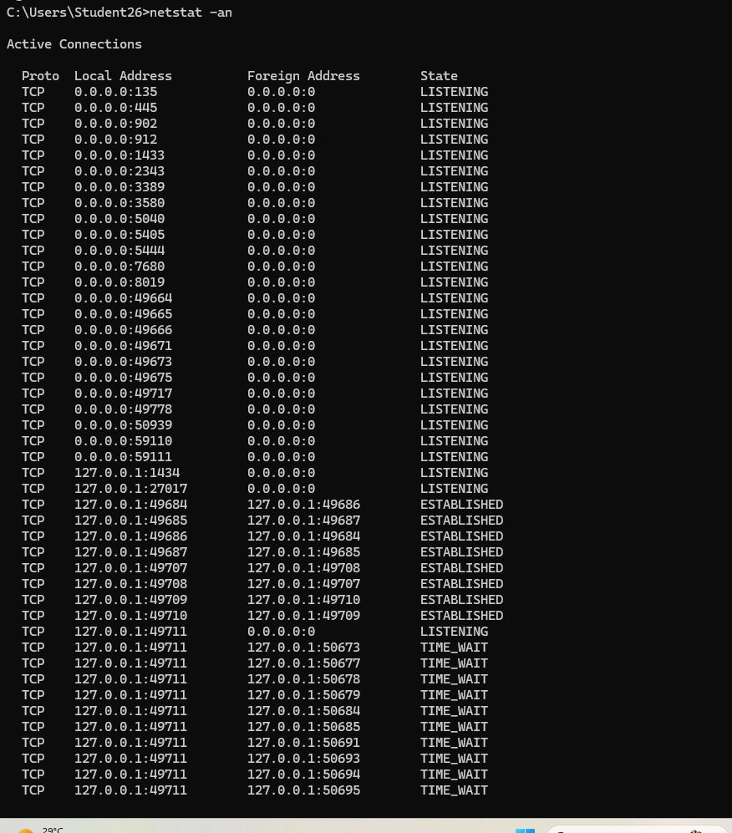
Command: netstat -an
Reason: To display active network connections, including the local/remote ports, connection status, and process ID of the aplications usping those connections.

Task # 6:
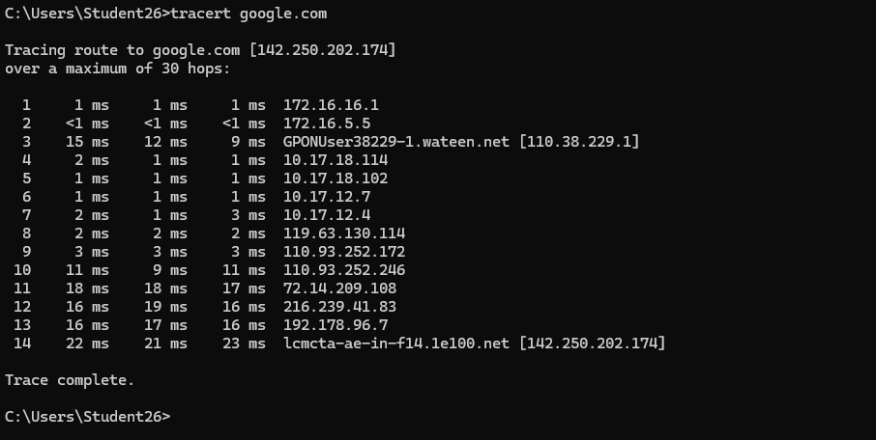
Command: tracert google.com
IP Address: 142.250.202.174
Hops: 14
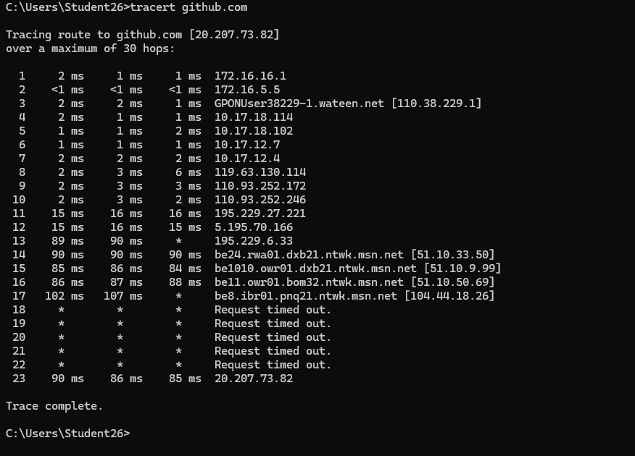
Command: tracert github.com
IP Address: 20.207.73.82
Hops: 23

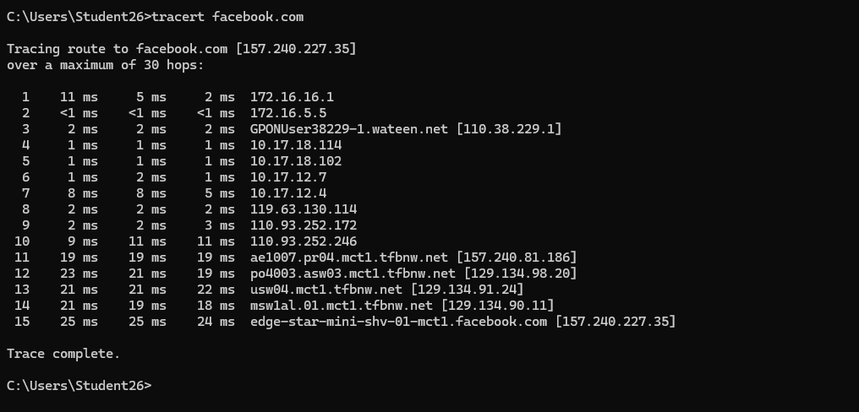
Command: tracert facebook.com
IP Address: 157.240.227.35
Hops: 15
Task # 7:
The DNS/name resolution is not working correctly, so the computer cannot translate “Syrin machine” into an IP address
Task # 8:
Straight-through cable
Task # 9:
Yes
Task # 10:
No
Task # 11:
Yes
Task # 12:
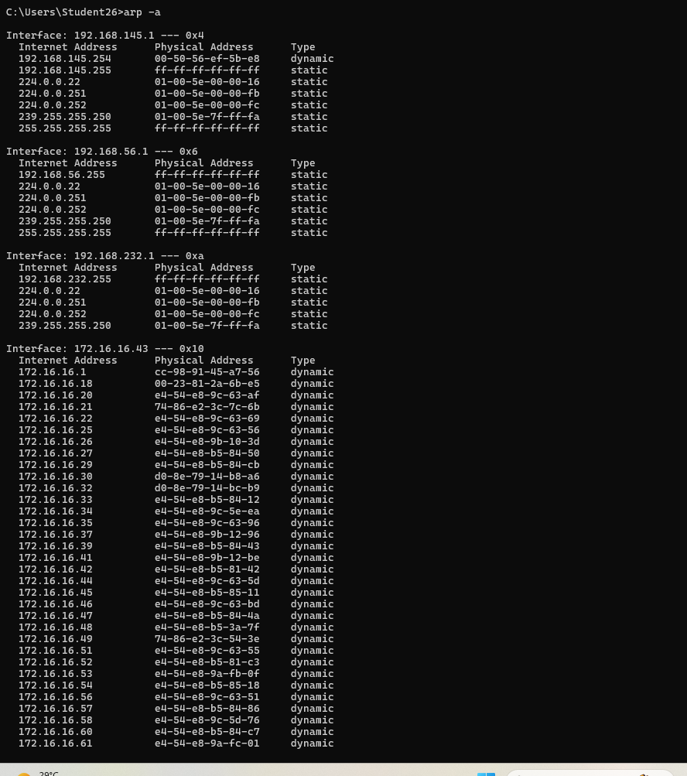

Task # 13:
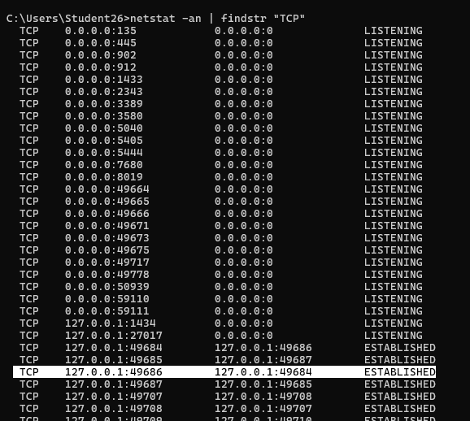

Task # 14:
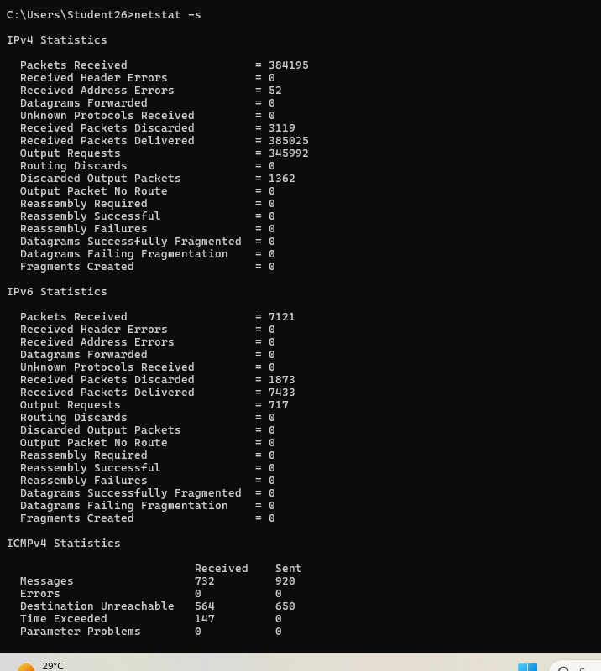

Task B:

Class Exercise: Address Class Identification:
Address | Class
10.250.1.1 | A
150.10.15.0 | B
192.14.2.0 | C
148.17.9.1 | B
193.42.1.1 | C
126.8.156.0 | A
220.200.23.1 | C
230.230.45.58 | D
177.100.18.4 | B
119.18.45.0 | A
249.240.80.78 | E
199.155.77.56 | C
117.89.56.45 | A
215.45.45.0 | C
199.200.15.0 | C
95.0.21.90 | A
33.0.0.0 | A
158.98.80.0 | B
219.21.56.0 | C

Class Exercise: Host & Network Identification:
Network Identification:
Address | Network Portion
177.100.18.4 | 177.100
119.18.45.0 | 119
209.240.80.78 | 209.240.80
199.155.77.56 | 199.155.77
117.89.56.45 | 117
215.45.45.0 | 215.45.45
192.200.15.0 | 192.200.15
95.0.21.90 | 95
33.0.0.0 | 33
158.98.80.0 | 158.98
217.21.56.0 | 217.21.56
10.250.1.1 | 10
150.10.15.0 | 150.10
192.14.2.0 | 192.14.2
148.17.9.1 | 148.17
193.42.1.1 | 193.42.1
126.8.156.0 | 126
220.200.23.1 | 220.200.23

Host Identification:
Address | Host Portion
10.15.123.50 | 15.123.50
171.2.199.31 | 199.31
198.125.87.177 | 177
223.250.200.222 | 222
17.45.222.45 | 45.222.45
126.201.54.231 | 201.54.231
191.41.35.112 | 35.112
155.25.169.227 | 169.227
192.15.155.2 | 2
123.102.45.254 | 102.45.254
148.17.9.155 | 9.155
100.25.1.1 | 25.1.1
195.0.21.98 | 98
25.250.135.46 | 250.135.46
171.102.77.77 | 77.77
55.250.5.5 | 250.5.5
218.155.230.14 | 14
10.250.1.1 | 250.1.1

Class Exercise: Network Addresses:
Network Address
188.10.0.0
10.10.48.0
192.149.24.0
150.203.0.0
10.0.0.0
186.13.23.0
223.69.0.0
200.120.135.0

Class Exercise: Host Addresses:
Host Address
0.0.18.2
0.0.0.80
0.0.0.11
0.0.230.19
0.10.10.10
0.0.0.11
0.0.23.20
0.0.0.215
Class Exercise: Default Subnet Masks:
IP | Class | Default Subnet Mask
103.236.162.56 | A | 255.0.0.0
162.252.172.41 | B | 255.255.0.0
180.181.68.221 | B | 255.255.0.0
203.134.40.41 | C | 255.255.255.0
211.26.68.46 | C | 255.255.255.0
17.255.253.65 | A | 255.0.0.0
1.128.96.254 | A | 255.0.0.0
108.161.213.25 | A | 255.0.0.0
12.198.43.9 | A | 255.0.0.0
211.27.133.39 | C | 255.255.255.0

